Storyteller



In this project you will use a language model to generate stories. You will use the same sort of artificial intelligence technology that powers tools like ChatGPT.

*This project assumes you already understand the basics of how language models work.   
  
If you haven’t already completed the “Language Models” worksheet, you will understand this project better if you do that worksheet before this one.*

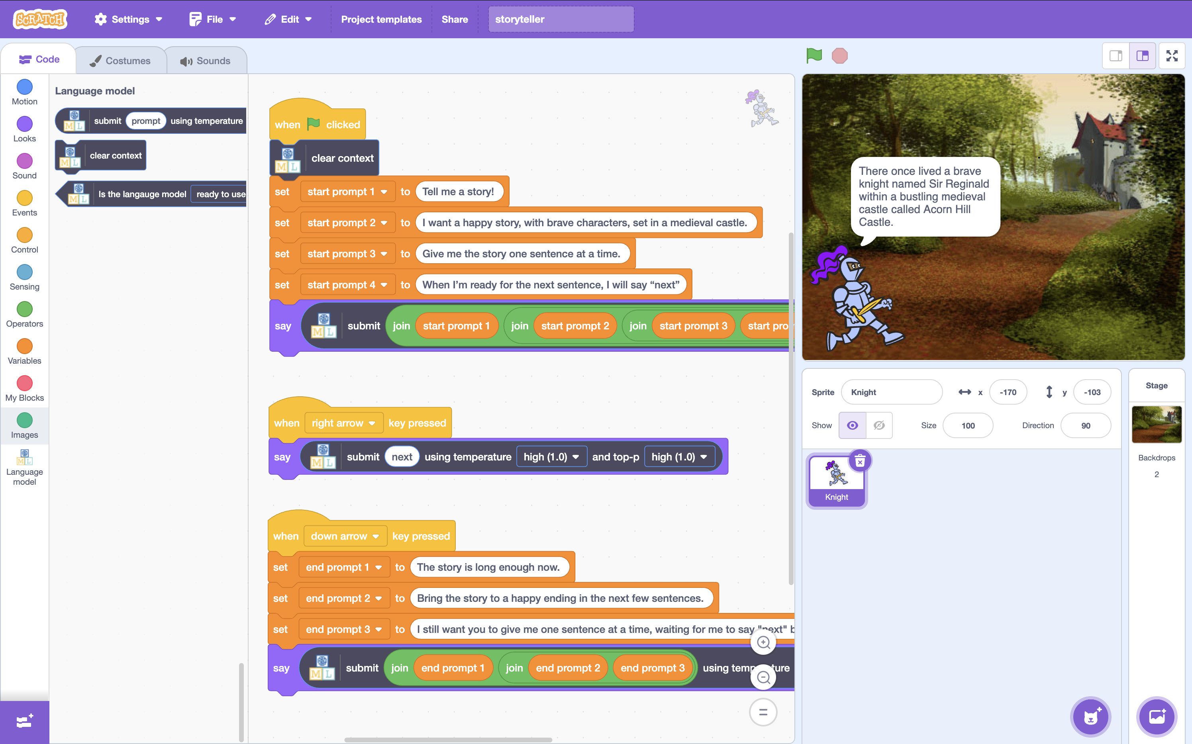

This project worksheet is licensed under a Creative Commons Attribution Non-Commercial Share-Alike License

http://creativecommons.org/licenses/by-nc-sa/4.0/

If you are under the age of 13, please only use a small language model with supervision from a trusted adult.

Generative AI can sometimes generate text that isn't nice or appropriate.

1. Go to <https://machinelearningforkids.co.uk/>
2. Click on “**Get started**”
3. Click on “**Log In**” and type in your username and password  
   *If you can’t remember your username or password, ask your teacher or group leader to reset it for you.*
4. Click on “**Projects**” on the top menu bar
5. Click the **“+ Add a new project**” button.
6. Name your project “**Storyteller**” set it to learn how to generate text.   
   Click **Create**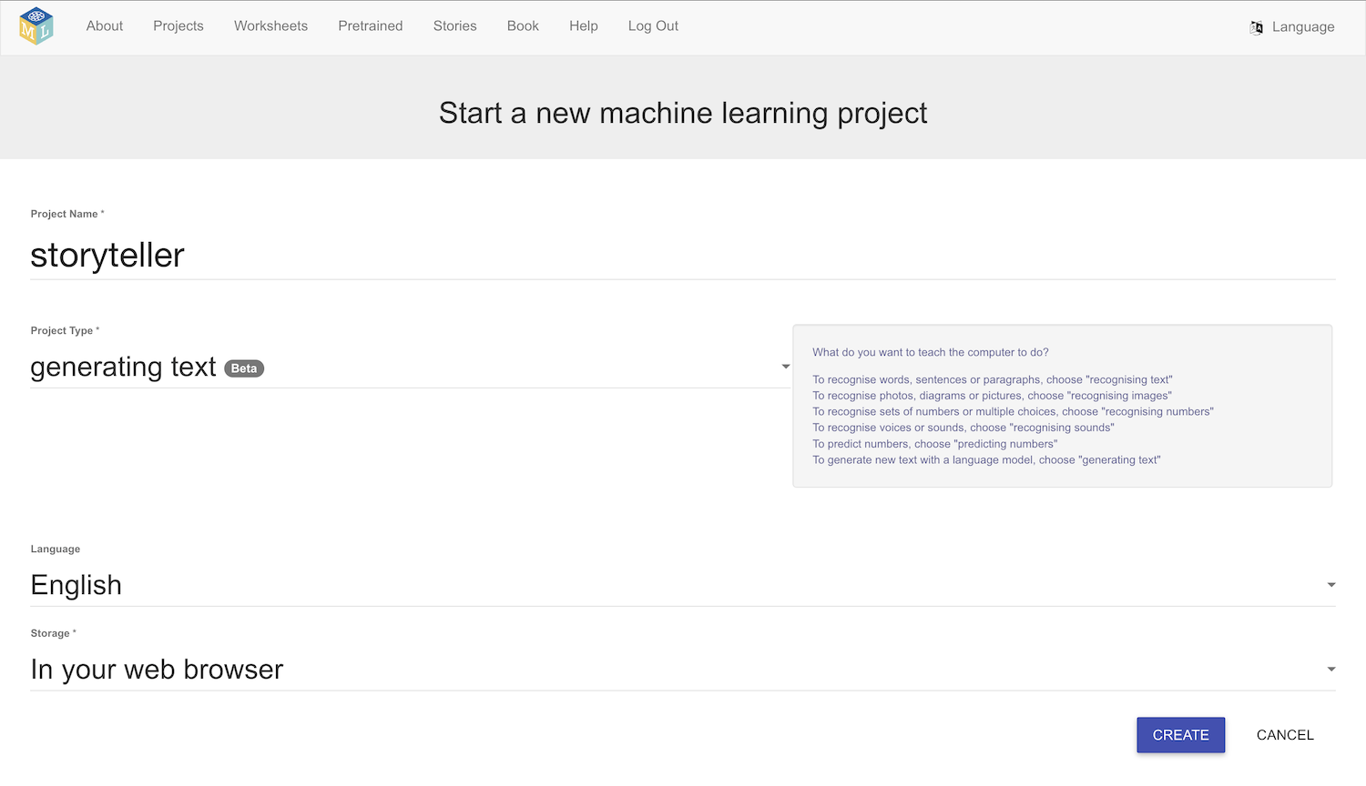
7. You should see your new project in the projects list. Click on it.
8. Click on **Small**, and then click **Next**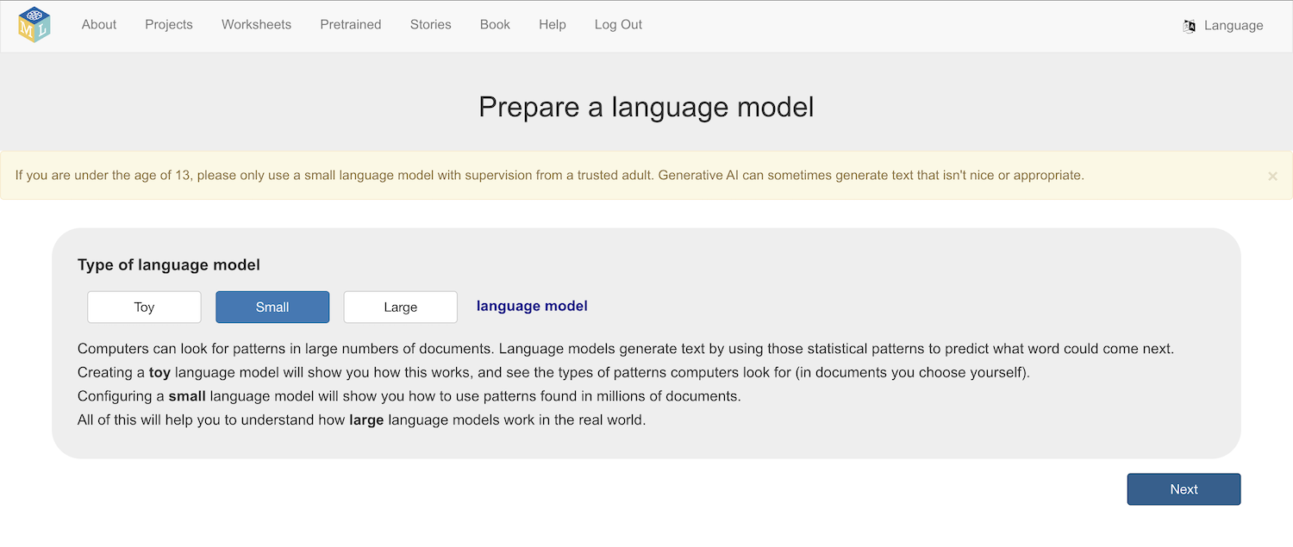
9. Choose a model architecture  
   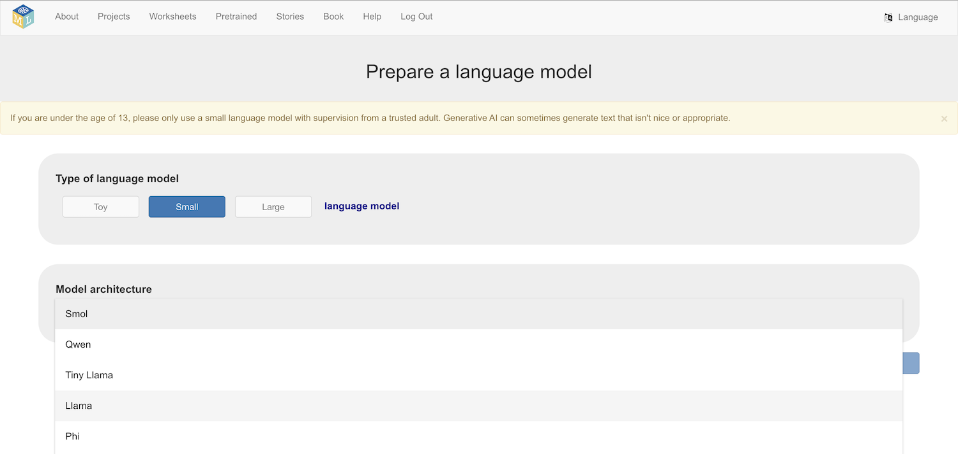  
    *There are multiple models to choose from.   
   “SmolLM2” (made by Hugging Face) – 276 MB download*

*“Qwen 2.5” (made by Alibaba) –289 MB download*

*TinyLlama (made by Singapore Uni. of Technology & Design) – 625 MB download*

*Llama 3.2 (made by Meta) – 711 MB download*

*Phi 1.5 (made by Microsoft) – 806 MB download*

*Gemma 2 (made by Google) – 1.5 GB download*  
*The larger models can generate better text, however they:  
* will take longer to download  
* will need more storage space on your computer  
* will need a faster and more powerful computer to run  
  
You can* ***change your choice later*** *if you don’t like the responses you get.*

1. Click **Download**
2. Set the context window size to **512**, and click **Next***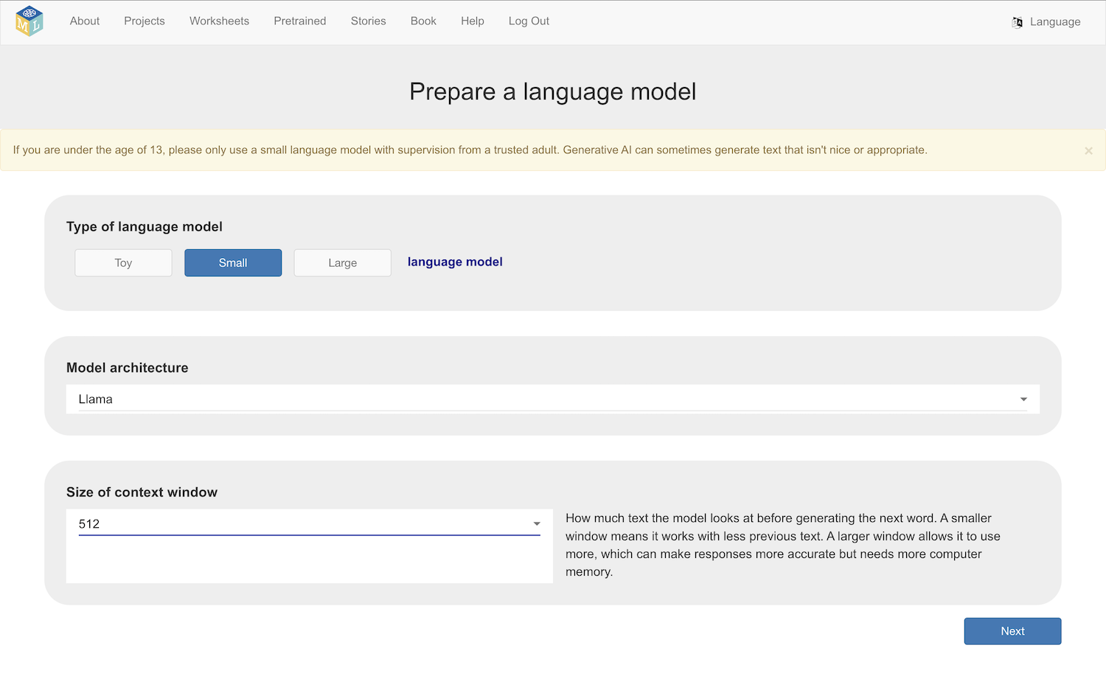*
3. Set a high temperature and Top-P value  
   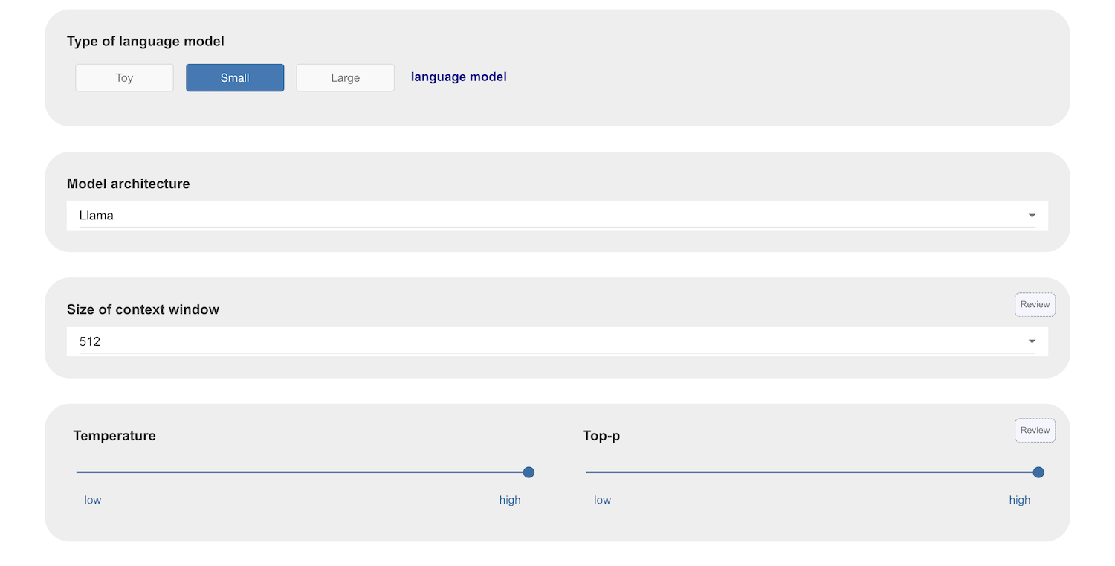
4. Click **Next**
5. Type a prompt asking for a story  
   *For example, I tried “****Tell me a story set in a medieval castle****”*  
   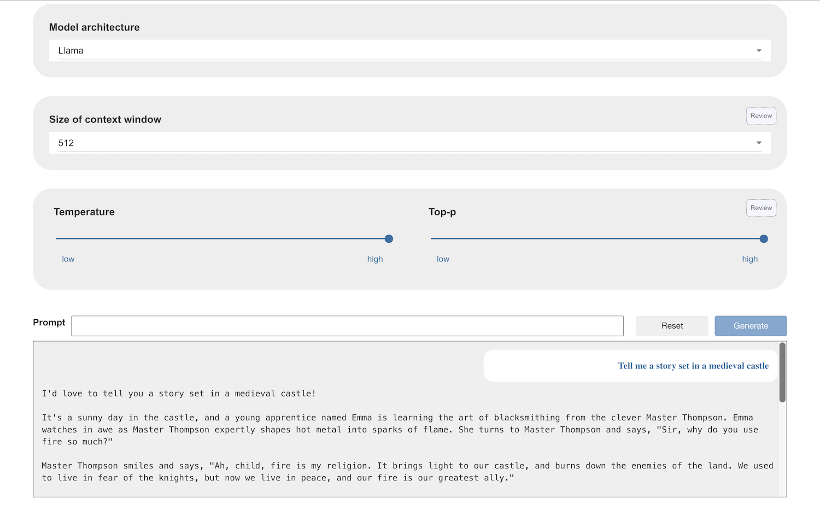
6. Click on **Reset** and then try the same prompt again  
   *With a high temperature and Top-p value, you should get different responses each time*  
   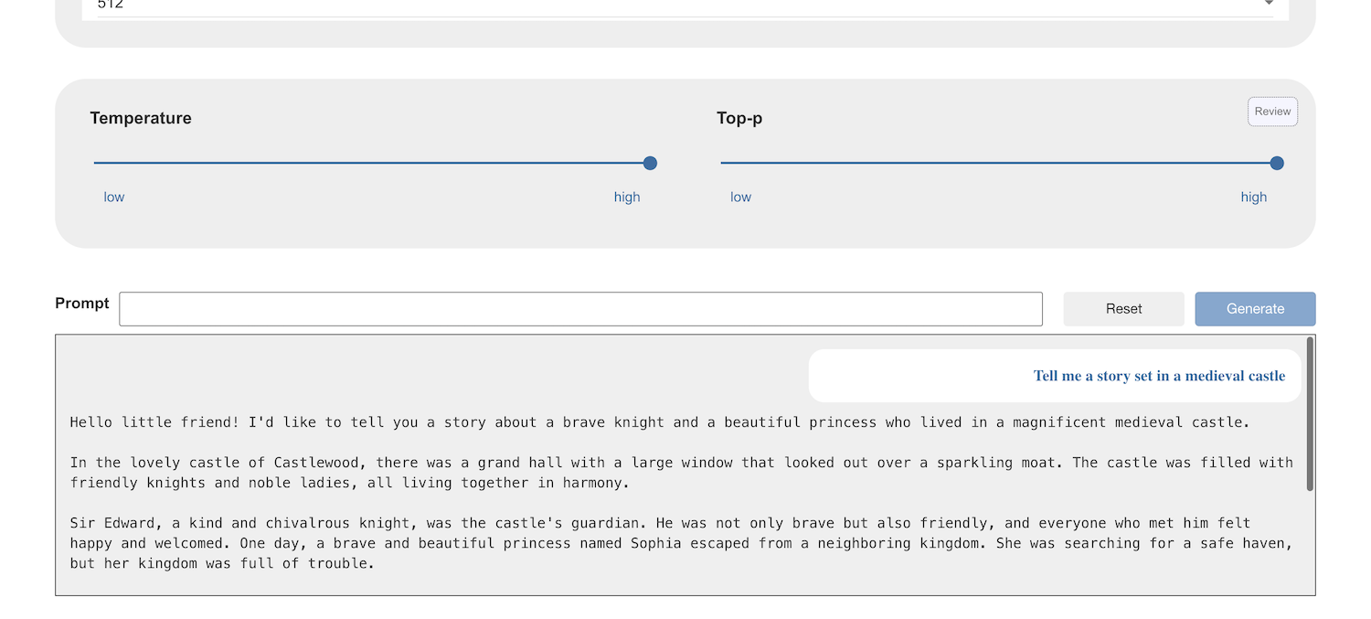
7. Experiment with different prompts to try and get the type of story you would like.   
   *Does it help to give more specific instructions?*
8. Click on the **Scratch 3** button  
   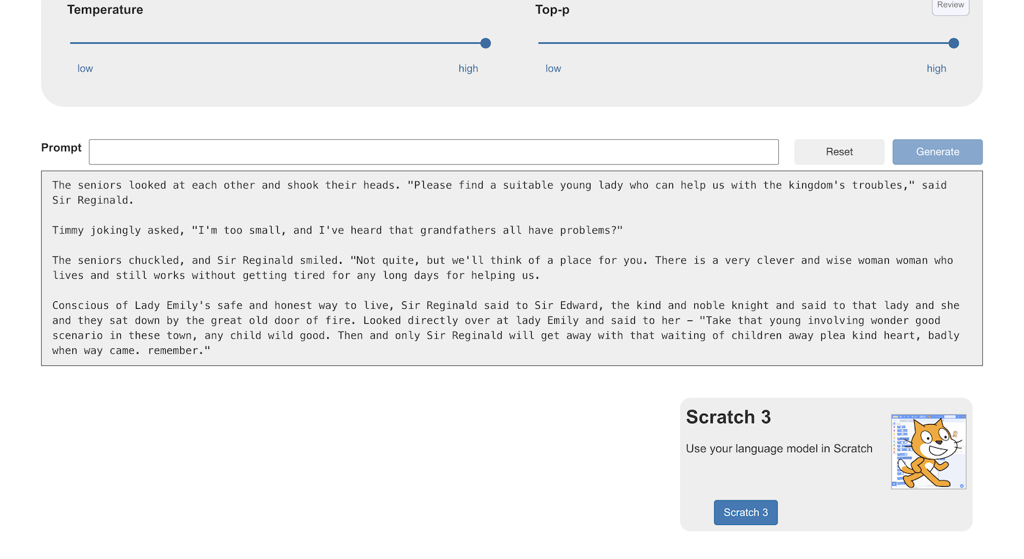
9. Create the following code  
   *Use your prompt instead of mine*   
   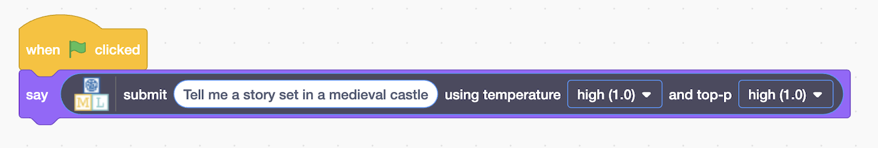
10. Click on the **Green Flag** to test   
    *The story is almost certainly going to be too long to fit in a Scratch* ***say*** *bubble.*   
    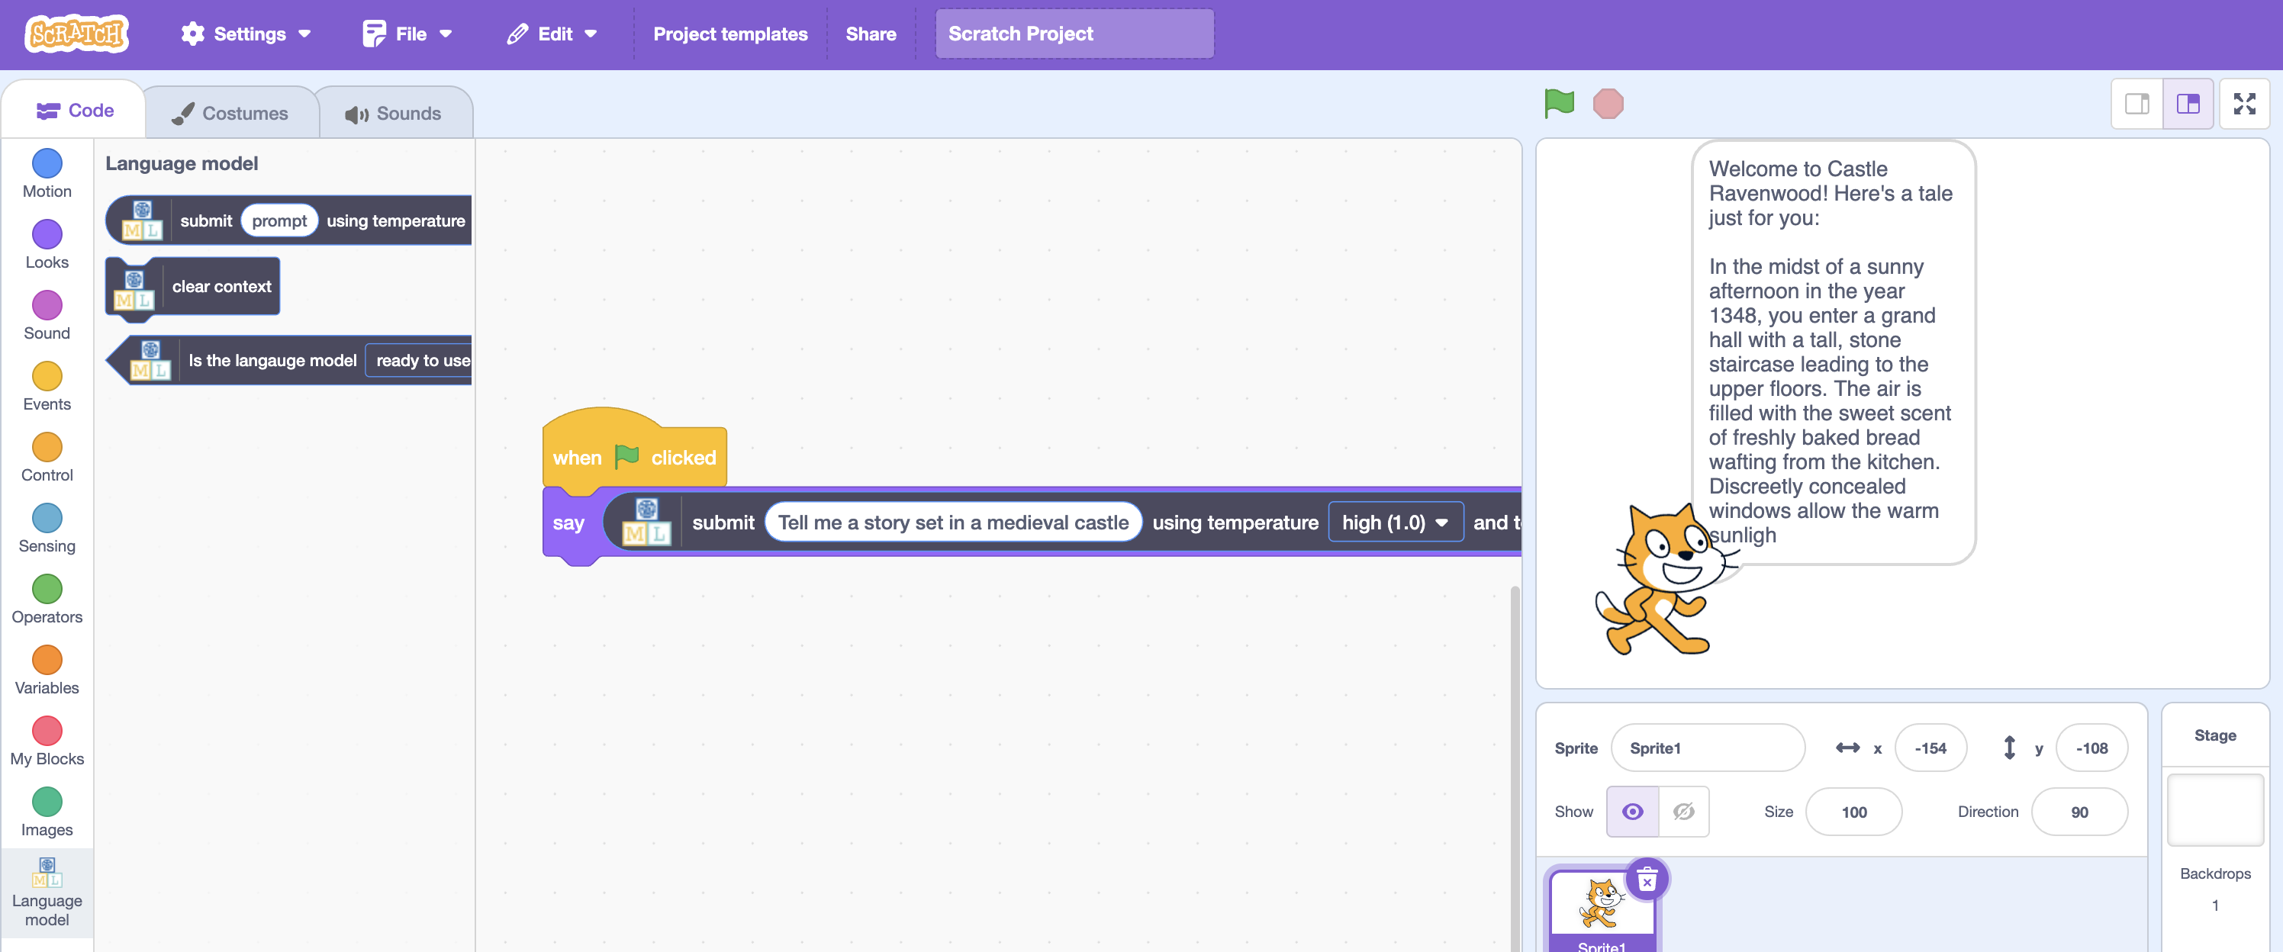
11. Close the Scratch window to go back to the training tool
12. Try asking the model for a story one sentence at a time. Tell the model that you want to ask for the next sentence. For example:  
    **Tell me a story! I want a happy story, with brave characters, set in a medieval castle. Give me the story one sentence at a time. When I’m ready for the next sentence, I will say “next”***You should just get the start of a story this time.*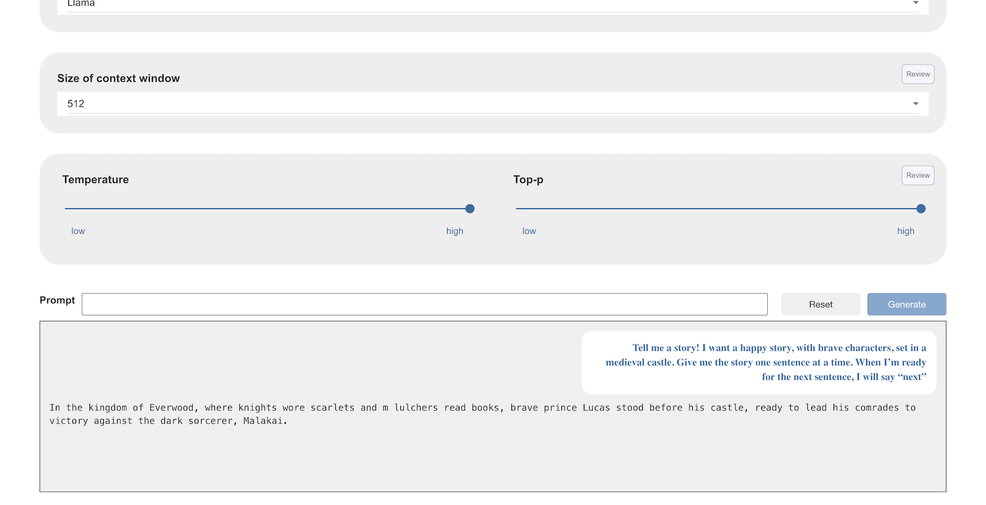
13. Use the **Reset** button to try different ways of asking
14. Ask for the next sentence, in the way that you said you would in your original prompt  
    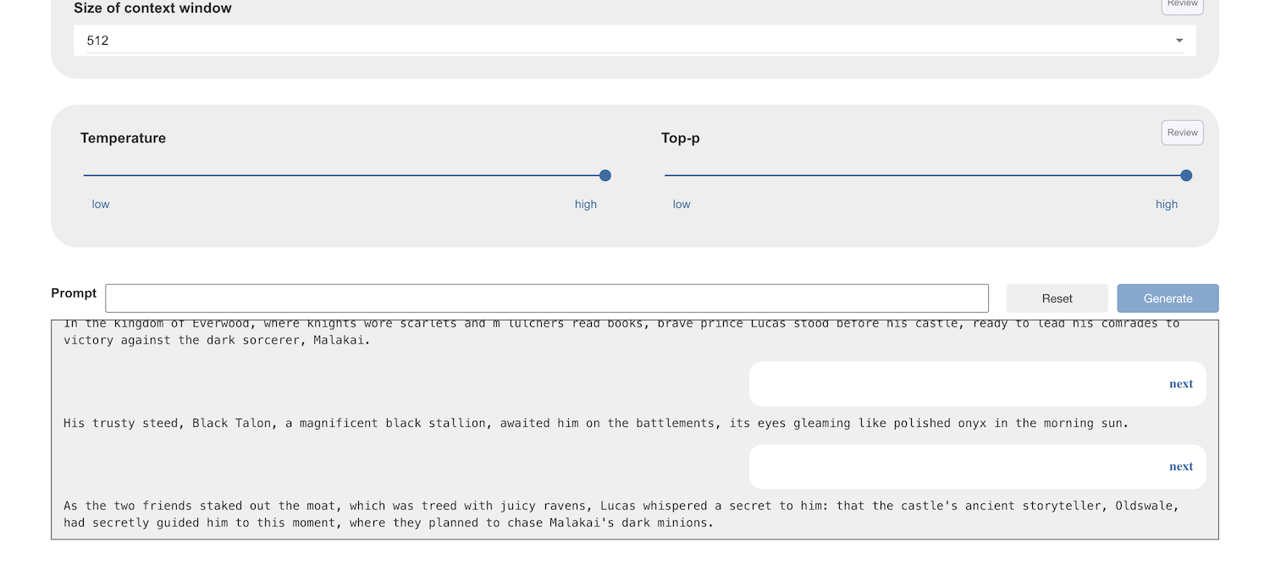
15. Keep going!  
    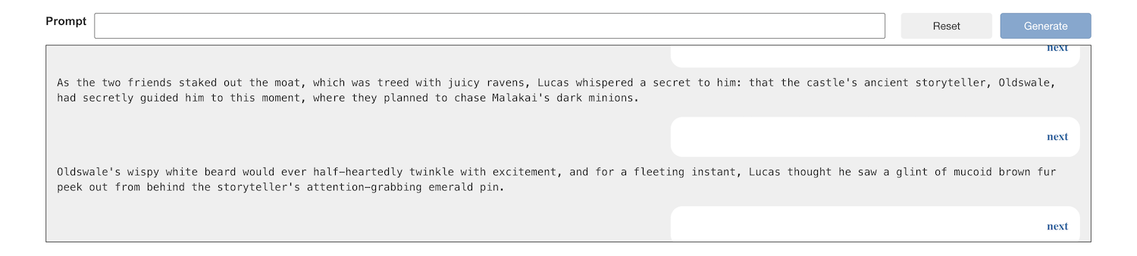
16. The text window shows the current **“context”** – which is like the model’s memory. The “**context window**” contains the information it is using to generate new text.   
    If you fill the context window, older text is removed. Once your story has got long enough, your original prompt will be removed.   
    Scroll to the top of the chat window and check if your original prompt is still there.   
    *Keep asking for the next sentence until it vanishes.*  
    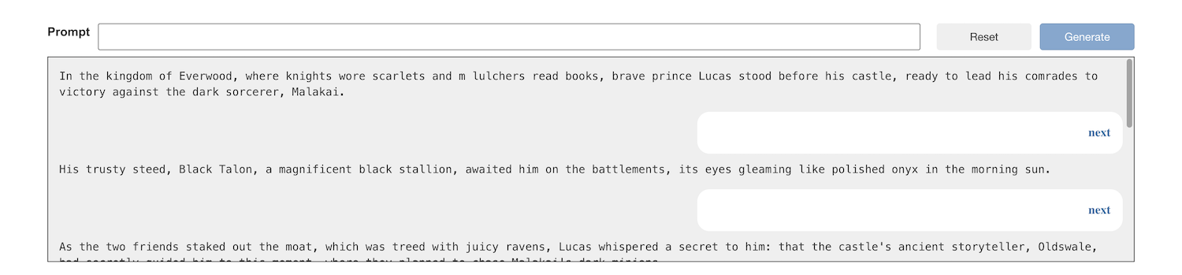
17. What happens if you ask for another sentence now?  
    *The model no longer has your original prompt in the context to know why you’re saying “next”.   
    If you’re lucky, the model might be able to infer the intention of the* ***next*** *command from previous interactions, but most likely it will result in something unexpected!*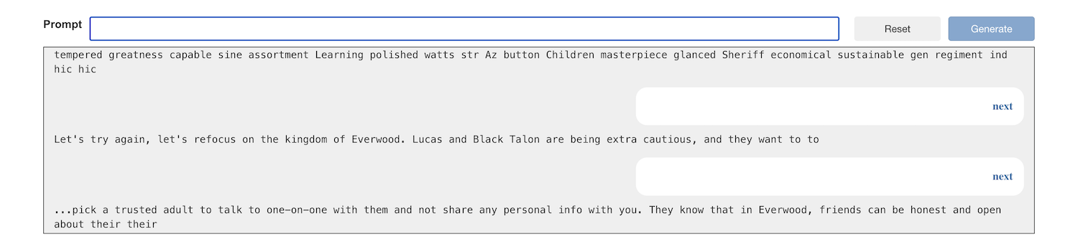  
    *Choosing a context window size of 512 tokens means you won’t be able to generate very long stories!*
18. Choose a larger context window  
    *The larger the context window, the better – but this requires is more complex for your computer to run.   
    If your computer isn’t powerful enough for a very large context window you will get an error. If that happens, choose a smaller option.*  
    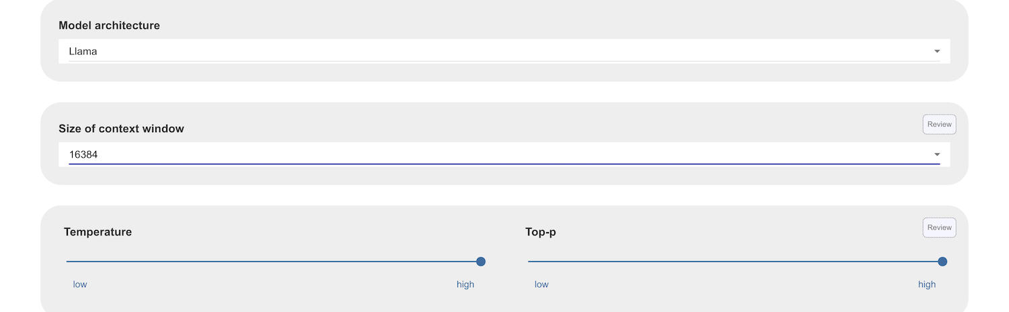
19. Try again, and see how far the story goes   
    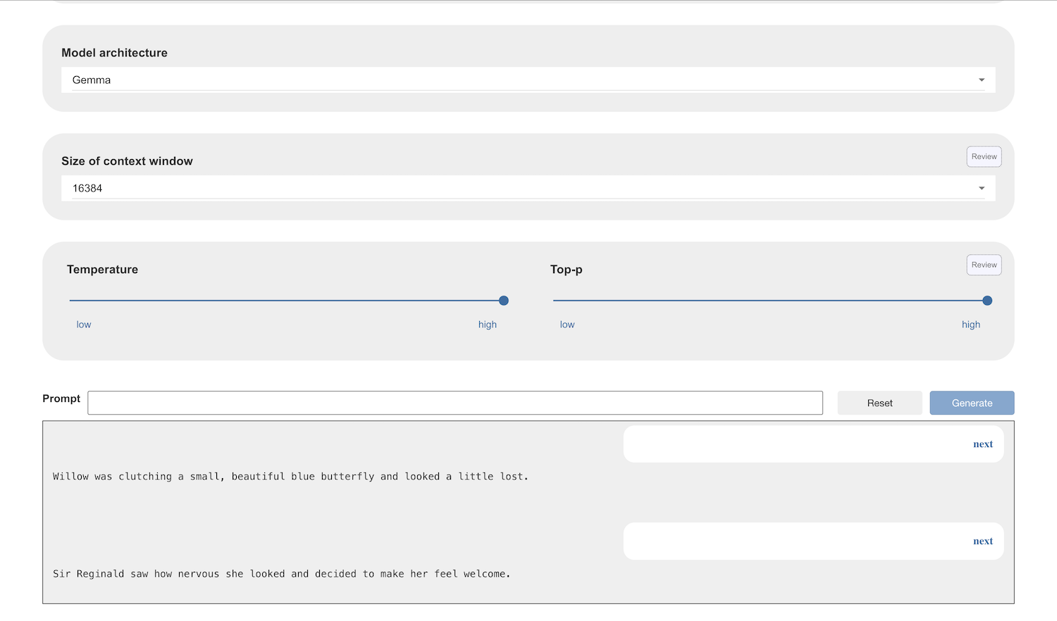
20. If you want the story to come to an end, ask for that.  
    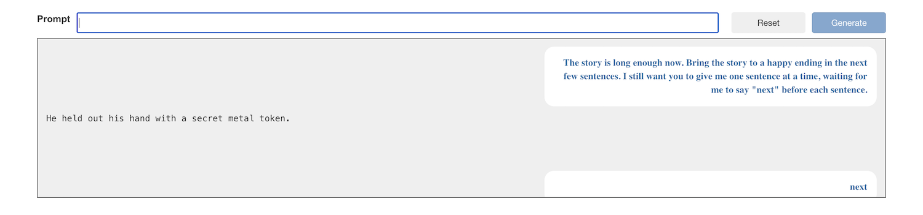
21. Click on the **Scratch 3** button again
22. In the Scratch window that opens:   
    - choose a **backdrop** suitable for your story  
    - choose a sprite **costume** suitable to be your storyteller  
    *You can draw these yourself if you prefer! Be creative!*  
    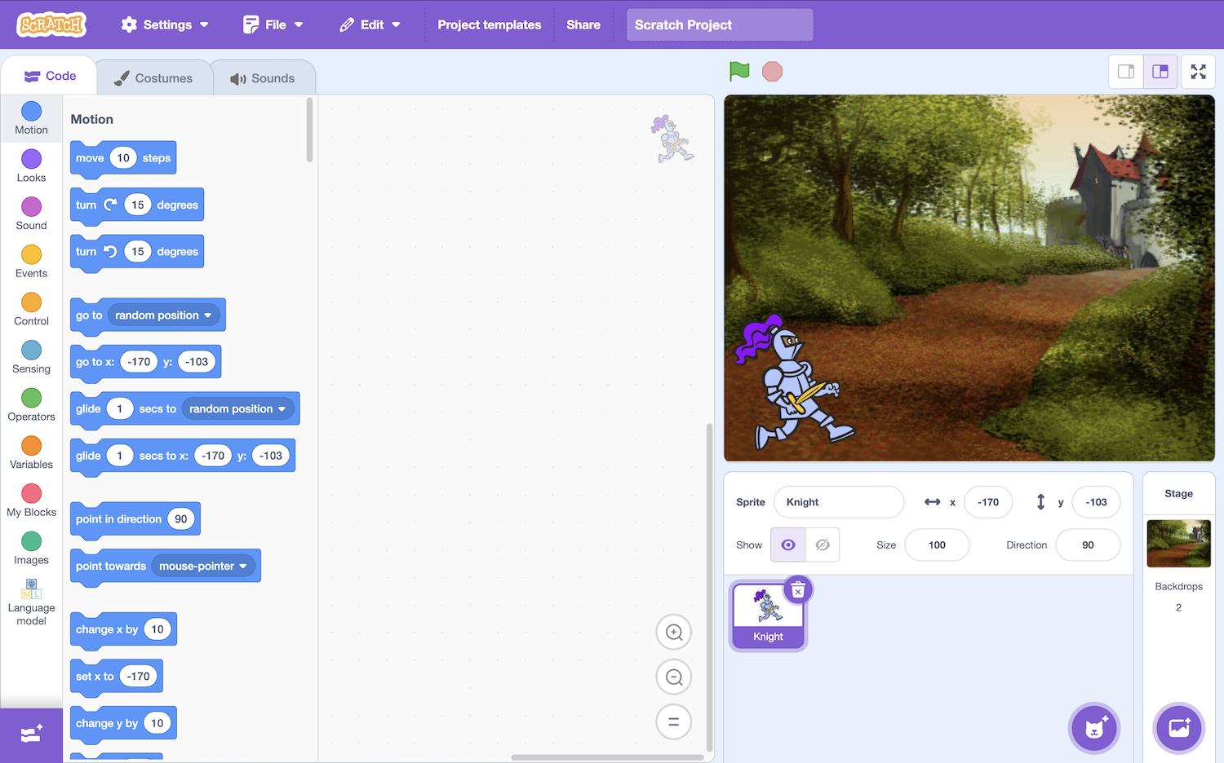
23. Create this code using the prompts that you’ve tested   
    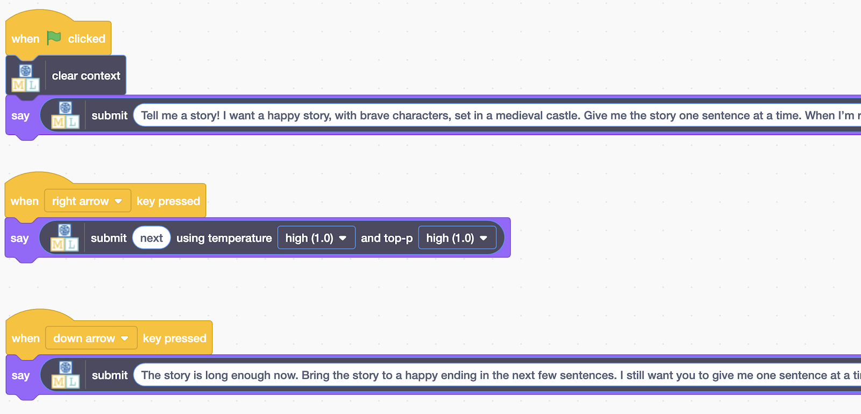
24. Test your project  
    *Clicking on* ***Green Flag*** *will start a new story  
    Pressing the* ***right arrow*** *key will get the next bit of the story  
    Pressing the* ***down arrow*** *key will end the story*  
    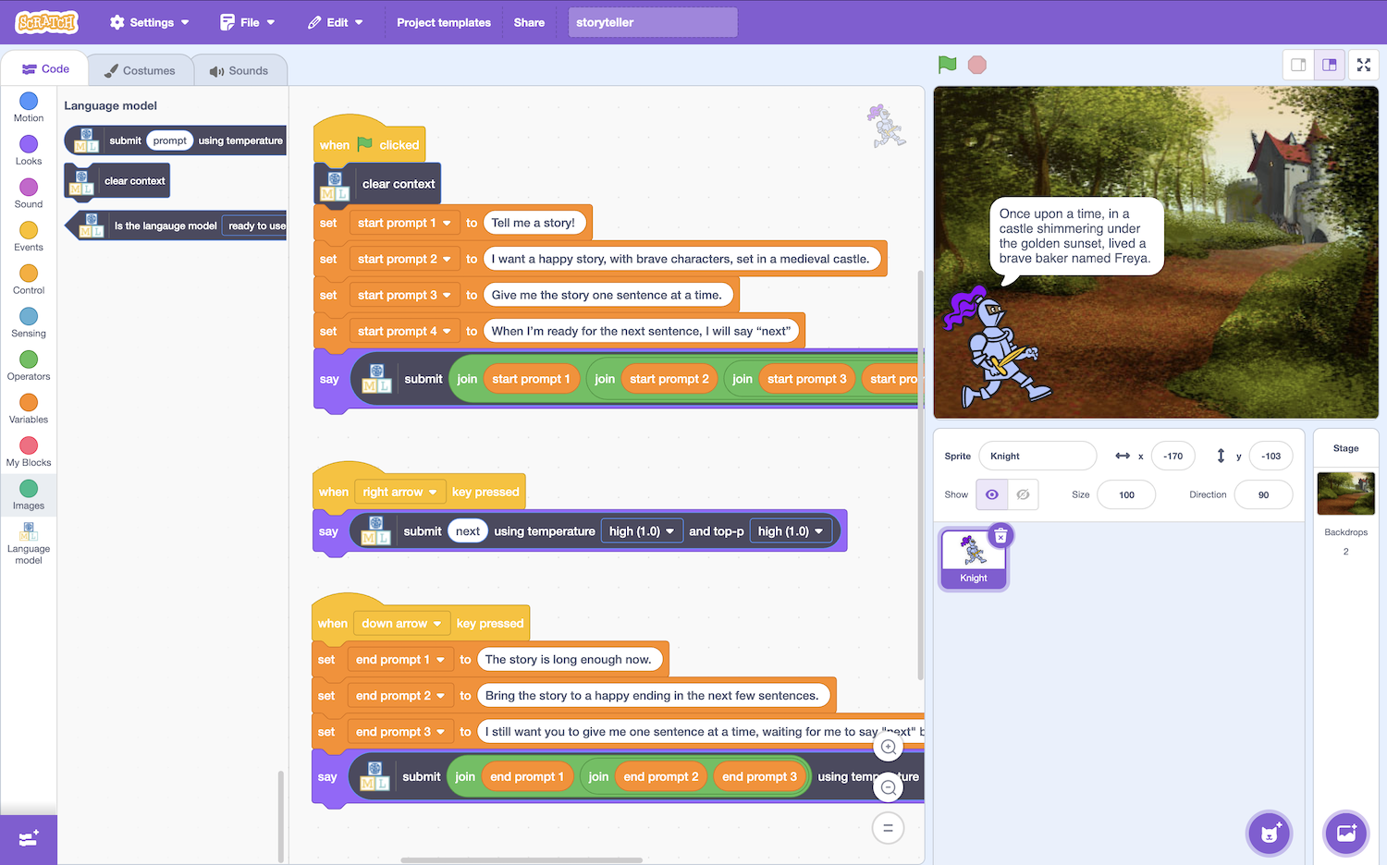 *Check that the model can end the story when you ask  
    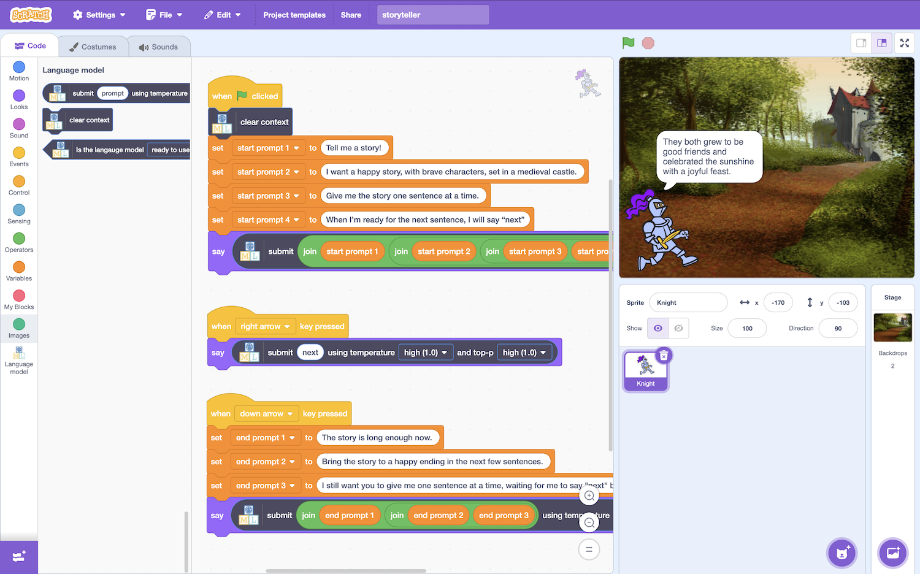*
25. Give your story teller a voice!  
    *Another use of artificial intelligence is “text to speech”.   
    Open the extensions panel  
    *
26. Add the **text to speech** extension to your project  
    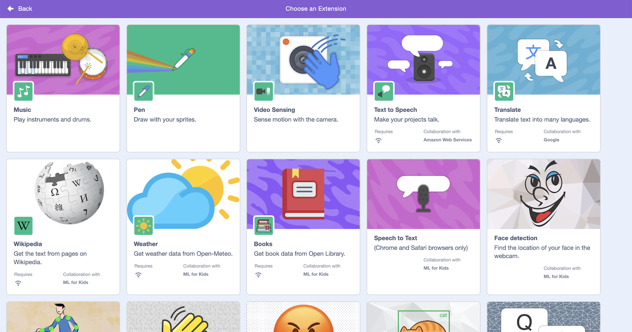
27. Choose a voice for your storyteller  
    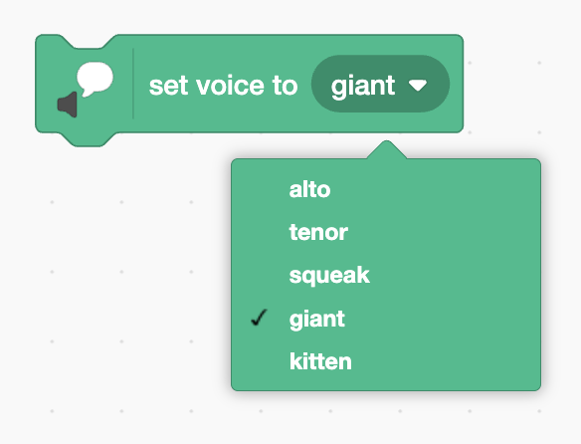
28. Add the **speak** block to your project  
    *Here is one way to do it. You don’t have to copy this.   
    Try and do it your own way.*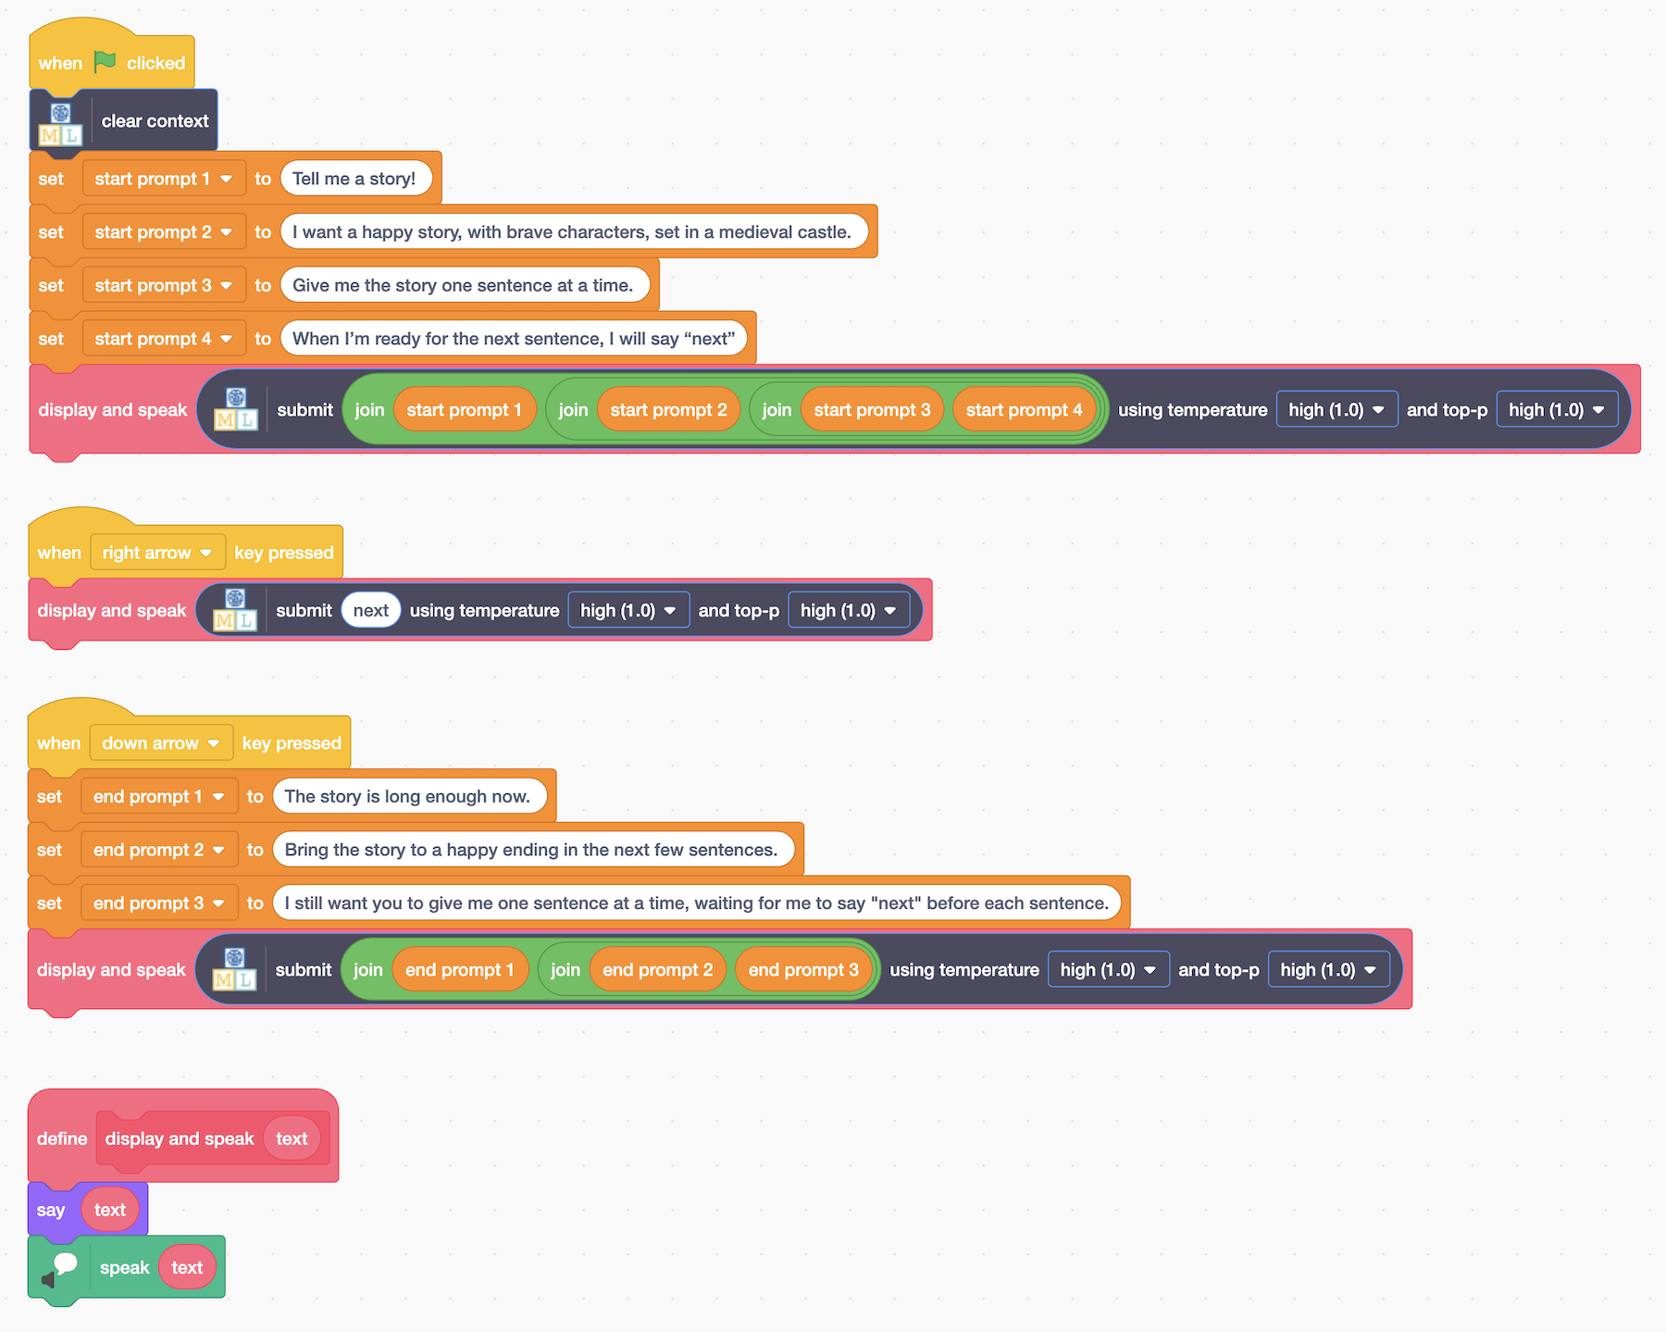
29. Can you make the storyteller move around the stage while it tells the story?

**Ideas and Extensions**

Now that you’ve finished, why not give one of these ideas a try?

**Try using your language model in Scratch**

Something

**Something else**

Details

**Finally**

Details